O’Connor, L., Cpl.
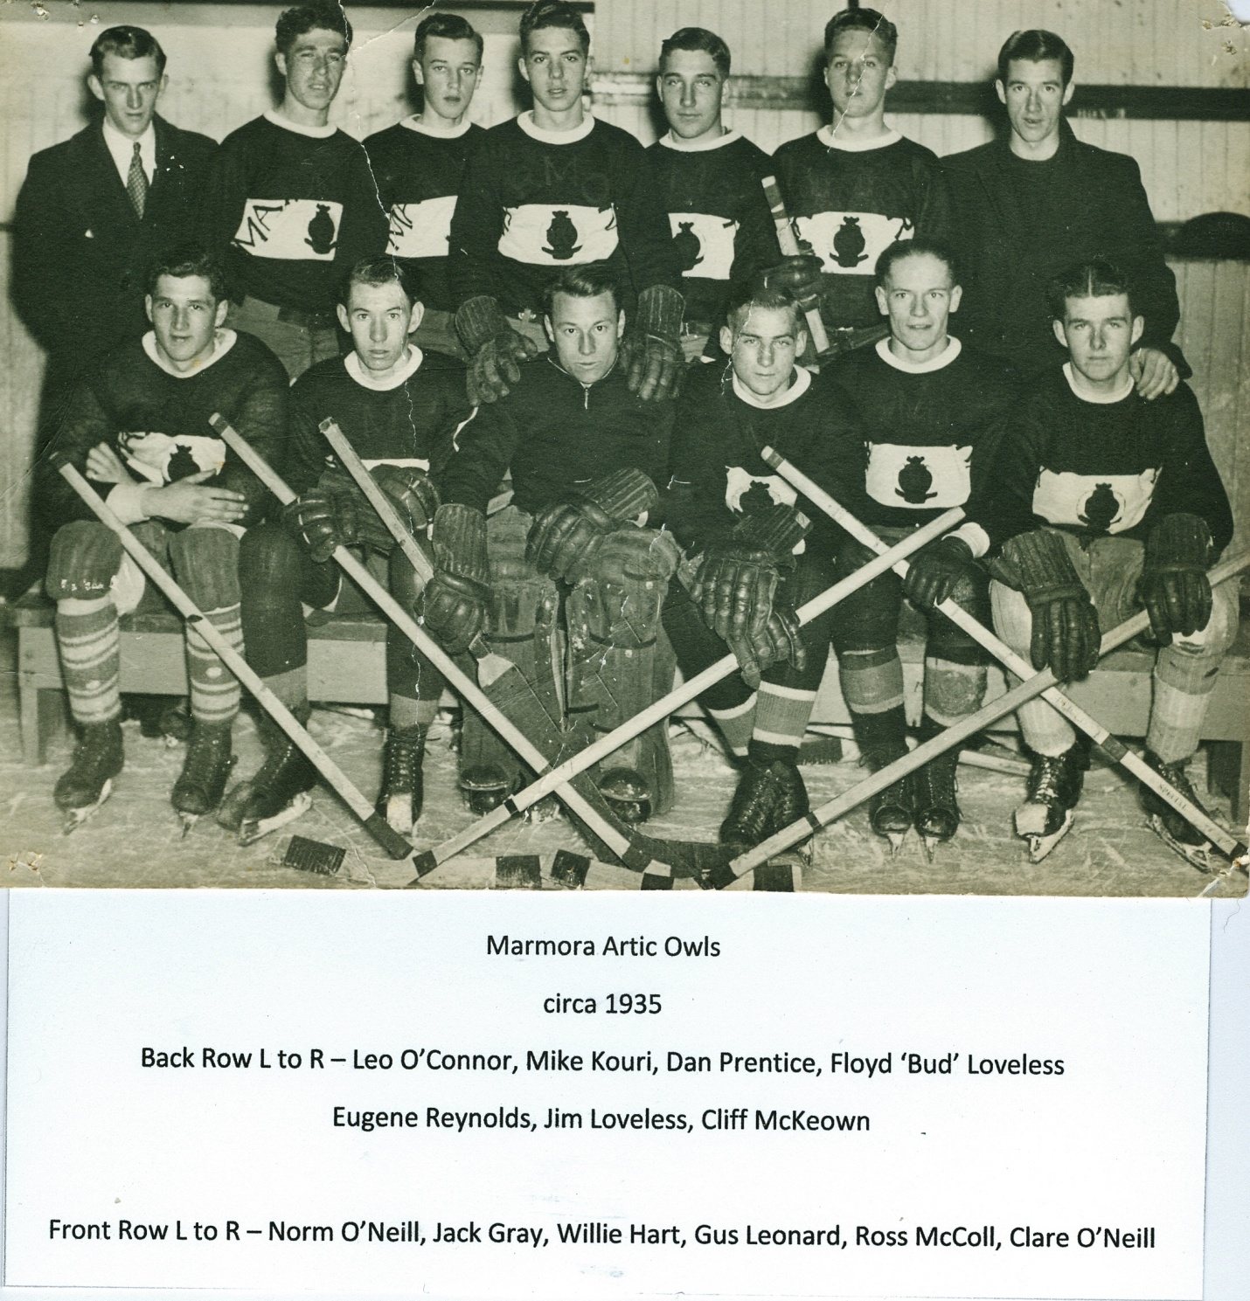
E52887 Corporal Leo O’Connor of the Princess Patricia’s Canadian Light Infantry was killed in action on 27 August 1944 and is buried at the Montecchio War Cemetery, Italy. Leo was born on 29 October 1917 at Marmora, Ontario. He was raised in Marmora where he graduated from high school with a junior matriculation. After his education he took employment with the local drug store of Mr. J.L. Shannon. Here he worked as a drug clerk for four years. Leo O’Connor was called up for service and reported on 10 January 1941 to the Hastings and Prince Edward Regiment before going on basic training with No.32 Canadian Army Basic Training Centre in Peterborough, Ontario. While undergoing training his mother passed away on 7 May 1941. He graduated on 8 February 1942 and a month later volunteered for active service. He was transferred to the Active Service Force on 11 March 1942 and was posted to the Royal Rifles of Canada in Quebec. The Rifles deployed to Vernon, British Columbia for defence of Canada tasks. He was promoted to Acting Corporal on 18 July 1942 and was posted to the Canadian Small Arms Training Centre in Nanaimo, British Columbia. At the training centre he completed his qualification course for Corporal. On 23 October 1942 he was confirmed in the rank of Corporal and rejoined his unit at New Westminster, British Columbia. On 16 November 1942 his father died. Cpl O’Connor received his orders for overseas deployment at the end of December and moved to Quebec City in order to prepare for deployment. He sailed for England arriving on 13 February 1943 and was posted to the 5th Canadian Infantry Reinforcement Unit. Corporal O’Connor was allocated to the Princess Patricia’s Canadian Light Infantry on 12 May 1943 as a reinforcement. He sailed with the invasion force on Operation Husky landing in Sicily after the initial assault but remained left out of battle. Cpl O’Connor joined the Patricias in the field on 28 September 1943. By this time they were in Italy preparing for the advance to Campobasso. Following the advance, Cpl O’Connor fought with the regiment during the crossing of the Moro River, the fight at Villa Rogatti, the assault on Vino Ridge, the Battle of Ortona and the defensive operations near Ortona and at Crecchio. The Patricias then moved to Liri Valley for the assault on the Hitler Line. On 23 May 1944 the 2nd Canadian Infantry Brigade would assault in the Forme d’Aquino area in an attempt to breach the Hitler Line. The Patricia’s attack was in the area between the gully of the Forme d’Aquino and the Aquino-Pontecorvo road. ‘A’ and ‘C’ Companies would assault with ‘B’ Company passing through on the objective. The two companies advanced at H-Hour and reached the enemy wire. At this point the enemy anti tank guns opened fire destroying the armour support. The Patricias continued without support and where hit by machine gun fire from the right flank and indirect fire causing them to be pinned down. The regiment fought with determination and bravery but was unable to reach their finial objectives. Meanwhile on the left the 1st Brigade broke through the line and the armour exploited the breach. Their part in the battle cost the regiment dearly with 61 Patricia’s killed. Cpl O’Connor was wounded in action during the fight at 1315 hours. He was hit by machine gun fire and evacuated by No.5 Field Ambulance to No.14 Canadian General Hospital suffering from gunshot wounds to the right upper arm and head Two days later he was transferred to No.1 Canadian General Hospital until recovering from his wounds and discharged on 16 June 1944. After rejoining the regiment, the Patricias moved to the line near Florence with a sector south west of the city. All four companies held the line against the German 4th Parachute Division in early August 1944. The Canadians now moved to the Adriatic for an advance up the coast and assault the heavily defended Gothic Line. By 23 August the Patricias were poised to advance towards the Metauro River. During the night of the 25th the regiment crossed the river with little opposition and established themselves on the highway. On 27 August the Patricias continued with the objective of the Monte della Mattera Ridge. They came under fire from the town of Monte Santa Maria on the left and Bravo Company swung left and attacked, routing the enemy first from a farm houses then the town. Meanwhile Delta Company on the right continued the advance and was stopped by fire from Monte Croci. The Patricias could go no further and dug in holding the ground taken. During the fighting on this day Cpl O’Connor was killed in action. He was originally buried near Isola Del Piano and after the war was laid to rest at the war cemetery. Cpl O’Connor was awarded the 1939-45 Star, Italy Star, War Medal and the Canadian Volunteer Service Medal with Clasp. He was the son of Richard and Rose Ann O’Connor of Marmora, Ontario. Cpl O’Connor’s next of kin was listed as his sister Mrs. Anna Evangeline Meehan of Marmora, Ontario. He was the brother of Earl O’Connor of Marmora, Charles O’Connor of Coppercliff, Ontario, Crawford O’Connor of Florence, Ontario, Hugh O’Connor of Coppercliff, Pat O’Connor of Marmora, Tom O’Connor who was serving in the army overseas and Mrs. Veronica Elizabeth Forestell of Marmora, Ontario.
Written by Blair Neatby
b_cneatby@theedge.ca

