Daniel Mack’s Story
EXCERPT FROM “IN THE LAND OF MY FATHERS”
by John W. Mack, Dartmouth Nova Scotia

Daniel Mack was born February 14, 1786, in Lyme, New London, Connecticut. His father Samuel Mack Jr. and his mother Polly Southworth eventually moved from Lyme to Montague, Franklin, Massachusetts, then on to Addison, Steuben, New York.

Daniel’s trip from Lyme, Connecticut to Addison, Steuben, New York would have been a long and difficult one. The distance would have been approx. 400 miles. To travel this would have taken a week or more. Except for its navigable rivers and a handful of canals, the interior of New England from 1700 to 1830s was traversed only by a network of dirt and gravel roads. Travel in the early nineteenth century was so much slower and more difficult than it is now. In New England in 1790, vehicles were few, roads were generally rutted and rudimentary, and traveling any distance was both slow and difficult. Children and poorer adults walked everywhere, and only a minority of farmers had horses and wagons. Many loads of freight were drawn not by horses but by much slower-moving oxen. With a good horse, it took from four to six days, depending on the weather, to travel from Boston to New York. And this was on the best roads, which ran between major cities along the coast. Inland, the roads were even worse, turning to impassable mud when it rained or to choking dust when the weather was dry.

Daniel’s grandfather was General Samuel Mack. He was born May 3, 1743, in Lyme, Connecticut. He married twice, first to Lydia Brainerd in 1758 and in 1797 he married Martha Rawson. He was one of the early settlers of Jefferson County, New York. He was an engineer and builder of large works. He constructed the Forts of Sackett's Harbor. He was a Colonel under General Jacob Brown in the War of 1812. As noted later, Daniel was also involved in the War of 1812. Samuel took a prominent part in the building of a dam at Waddington, in the St. Lawrence River, to Ogden Island, thereby accomplishing a work others were loath to undertake. Samuel died on June 18, 1819, In Lyme, Connecticut.

Genealogical researchers believe that Daniel’s father was Samuel Mack Jr. born in 1743 in Lyme Connecticut and died in 1865 in Tuscarora, New York. In reviewing census data from Connecticut and New York during Samuel’s lifetime, he can be found, however, there is no mention of Daniel. Samuel was a popular name in the Mack family, and this has led to a lot of confusion by even the best genealogist. Samuel Mack Sr. is often mistaken for his nephew Samuel, the son of Solomon Mack. This Samuel had also married someone named Lydia Brainard. When Daniel was born his father and his mother were only fifteen years old. Unlike today it was common then for people to marry at such a young age. It is assumed therefore that Samuel Jr. and Polly were Daniel’s parents.
From the Mack and Sine Families Book by Dr. Harry Mack:
Samuel Mack Jr is listed in Lyme in the 1790, 1800, and 1810 census. He had six sons and three daughters. William Marvin City Clerk in charge of land records of Lyme, and having been Clerk for many years (he is also a descendent of the Marvin’s of Proprietorship days, a Samuel Marvin was a witness to the Will of John Mack the first) gave it as his opinion that Samuel Mack Jr was a son of the Samuel Mack of 1800 and 1810 census, a son of Jonathan although he did not find that Samuel transferred any land to Samuel Jr although both held lands at that time. The last transfer of land by Samuel Jr was in 1807.
The 1820 census lists only three Mack families in New London County, the heads of these were Ruth, Elijah, and William. Samuel Mack Sr would have been 77 years of age, probably deceased while Samuel Jr. and Erastus Mack and their families had moved northward or westward according to the migrations of many people at that time. In Lyme at the present time, there is Land known as Mack’s Land, Mack Creek, and in the local cemetery, there are many Mack Headstones.
The tombstone at Wellman's Corners, Rawdon Township, Hastings County, Ontario gives the death date of Daniel Mack as August 13, 1874, and he was aged 88 yrs., 5 months and 27 days thus born Feb 14, 1786. According to the writer’s father, Daniel was born in Lyme Connecticut, was one of nine children, and a descendant of the early Mack of Lyme. The Genealogies account for all Mack boys in Lyme under 16 years of age in the 1790 census except for the son of Samuel Mack Jr. In the 1800 census, there was only one boy listed between 10 and 16 years of age and the father of that boy was Samuel Mack Jr. Daniel was 14 years of age in 1800. Thus, it is certain that the father of our Daniel Mack was Samuel Mack Jr. In the 1810 census living with Samuel Jr. were two sons under ten, one son between 10 & 16, one daughter under ten, one between 10 & 16, and Samuel & his wife under 45. Thus, from the 1800 census one daughter had left home or was deceased, and three sons one of whom was Daniel. It is our family’s knowledge that Daniel left home soon after 1800. There was an Erastus Mack married with a daughter under 10 years of age listed in Lyme in 1810 he and his wife were under 26 years of age; I think Erastus was a brother of Daniel. I have no knowledge as to the name of the mother of Daniel.
Daniel’s siblings were:
David was born on April 23, 1792, in Lyme, Connecticut. He married Dorcas Lamphear in 1823. They had three children. He died on March 16, 1867, in Greene, New York at the age of 74.
Abigail was born in 1792 in Connecticut. She married Simeon Higgins in 1810 in New York. They had three children. She died in 1862 in Tuscarora, New York at the age of 70.
Enoch was born in 1794 in Lyme, Connecticut. He died in 1860 in Steuben, New York at the age of 66.
John William was born in 1796 in Lyme, Connecticut. He married Mary Seamans on December 10, 1816, in Campbell, New York. They had 11 children in 32 years. He died in 1878 having lived a long life of 82 years.
William was born on December 30, 1798, in Lyme, Connecticut. He married Eliza Kimball, and they had five children together. He then married Maria Albee and they had seven children together. He died on April 16, 1877, in Tuscarora, New York, having lived a long life of 78 years.
Mary was born in 1798 in Lyme, Connecticut. She had one son and two daughters with Asaph Johnson between 1823 and 1839. She died in 1870 in Woodhull, New York, at the age of 72.
Samuel was born on September 2, 1800, in Lyme, Connecticut. He married Polly Johnson in 1819 in Chenango, New York. They had seven children in 26 years. He died on November 11, 1865, in Troupsburg, New York at the age of 65.
Zadock was born in March 1802 in Lyme, Connecticut. He married Fairzina M. Emerson on September 14, 1823. They had six children in 24 years. He died on April 16, 1877, in Tuscarora, New York having lived a long life of 75 years.
Why Daniel left the company of his brothers, sisters, and parents is unknown. It may be that he had different political views than his father. As noted, his grandfather, Samuel Mack Sr. was a General and likely a patriot of the United States. Daniel may have had Loyalist views. This was not uncommon during the late 1700s and early 1800s as thousands of Loyalists left the United States during this period. Families were divided over loyalty to the crown and patriotism to the newfound republic. The initial wave of peoples that would become known as United Empire Loyalists would begin around 1780. We do know that Daniel eventually made it to Canada around 1800.
His trip to Wellman’s Corner is about 330 miles from Steuben, New York. We are not sure if he traveled alone, by caravan, or with others. The trip would have likely been harder than the one from Lyme to Steuben as this direction had fewer roads. He would probably have crossed the St. Lawrence River near Kingston, Ontario.
He had a long siege of Typhoid Fever and for his care, he became indebted to a family named Warren in Frontenac County. How long he was ill and in their care is unknown. He would have had to have worked for the care the family gave him. He eventually worked his way for passage to Meyers Creek in Bellville on a flat-bottomed boat and later got a job cutting oak stave bolts and splitting them for both Rosebush and Chard families. The Rosebush and Chards were early pioneers in this area.
Daniel married Mary Polly Chard in 1814. Polly’s mother was Catherine Rosebush who married her father Barcelona Chard. Catherine’s father Joseph Rosebush owned a mill in Sterling. Polly’s first marriage was to Nehemiah Hubble II. She and Nehemiah had three children, Mary Nancy, Barce, and Nehemiah Hubble III. Nehemiah and Polly had obtained Lot 19 Con 3 from the government but were only able to clear a few acres and had a small log cabin. Nehemiah was known as “Big Myer” and he served in the Militia in the War of 1812. He passed away before the birth of his third son Nehemiah Hubble III on February 12, 1812. He is buried in Hubble Hill Pioneer Cemetery. Hubble can also be spelled, Hubbell.
After Daniel and Polly married, they continued to live on this land, clearing many more acres and building a larger house and barn. When the Hubble children were nearing adulthood Daniel bought the west half of Lot 19 Con 6 from Tom Wellman for twenty-six pounds on January 15, 1828. Here they built their home from the trees and stones found on their property, again clearing more land. They turned over to the Hubble Children Lot 19 Con 3 with all the improvements.
Their son William Mack bought the south half of their lot from them on June 20, 1857, and in 1861 Daniel and Polly were living with them. Soon thereafter they started living with their son David across the road.
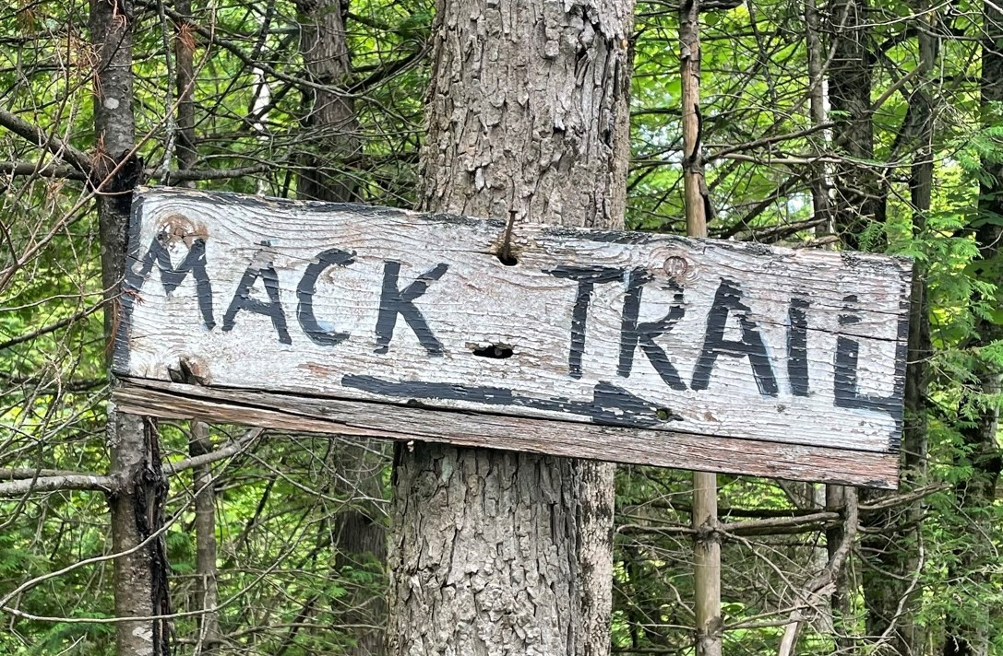
Mack Trail Sign, 4th Concession, Northumberland Side
David bought the south half of Lot 19 Con 6 from William on September 12, 1868, for $700. David tore down the old house and built a new one moving into it. Daniel and Polly lived the rest of their lives there with David. In 1828 Daniel and Polly were only the second residents that far north in the township. Polly and Daniel attended so-called “bees” for many social contacts and religious services that were held in each other’s homes until schoolhouses were built.
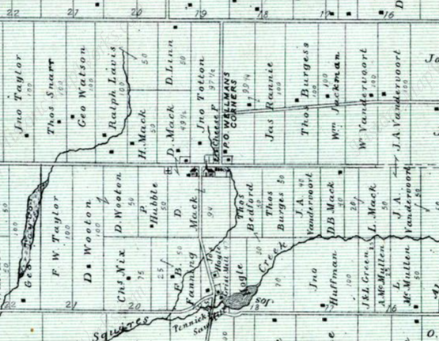
Portion of 1850's Rawdon Township map
Polly was built as a strong and muscular woman capable of doing a man's work. Daniel was small in stature and full of grit and stamina, weighed 140 pounds, and retained his black hair until his death. It was said that Polly could lift Daniel and all that he could carry at the same time. She could handle the large end of the backlog for the fireplace. Daniel would walk many times to Meyers Creek and back within a day.
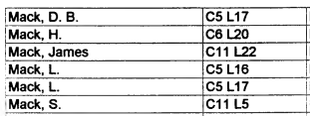
A portion of Index to Rawdon landowners in Belden Atlas
Daniel and Polly had eight children in 11 years.
Daniel Mack was born on April 16, 1814, in Hastings, Ontario. He had one son and four daughters with Mary Polly Benedict between 1834 and 1851. He died on March 4, 1877, in Tunnel City, Wisconsin, at the age of 62.
Lewis B Mack was born on March 15, 1817, in Hastings, Ontario. He married Harriett Ann Reid in 1836 in Wellman, Ontario. They had six children in 22 years. He died on March 23, 1897, having lived a long life of 80 years.
David Mack was born on August 19, 1819, in Hastings, Ontario. He married Elizabeth Althouse, and they had ten children together. He then married Clarissa Sine and they had one son together. He died on March 20, 1884, at the age of 64.
The infant Girl was born in 1822 and passed away that same day.
Erastus Mack was born on August 31, 1824, in Hastings, Ontario. He married Maria (Mariah) Hughs on August 12, 1844. They had 13 children in 23 years. He died on August 12, 1894, in Loyal, Wisconsin, at the age of 69.
James Mack was born in 1827 in Hastings, Ontario. He married Jane Woods, and they had seven children together. He also had two sons and one daughter with Anne Woods. He died on September 9, 1896, in Northumberland, Ontario, at the age of 69, and was buried in Rylstone, Ontario.
Nicholas Mack was born in 1827 in Hastings, Ontario. He died in 1894 at the age of 67.
William D. Mack was born in 1828 in Hastings, Ontario. He died on April 10, 1905, having lived a long life of 77 years.
During the War of 1812, Daniel was mustered into the 1st Hastings Militia on March 18, 1813, under Captain Simon McNabb. This militia regiment was created informally as early as 1798.
Nehemiah Hubble was first listed in the muster rolls on October 12, 1799, in Rawdon along with his son Nehemiah Hubble Jr.
The Regiment was under the command of Colonel John Ferguson. Records are preserved in the Public Archives of Canada at Ottawa, Nominal Rolls. There were 96 men in this muster roll. Some of these men were United Empire Loyalists who fought in the American Revolutionary War as well as the War of 1812.
Daniel is also listed with the 1st Regiment Hasting County under Major Simon McNabb dated June 4, 1818.
For his service, Daniel was granted land in Rawdon in 1842.
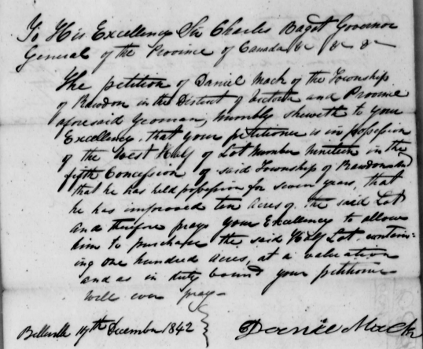
Copy of a portion of Daniel's Land Petition
Daniel and Polly were like many others at the time in that they were active in their faith and community. Family land was ultimately given over to build a church, cemetery, and schoolhouse or community building.
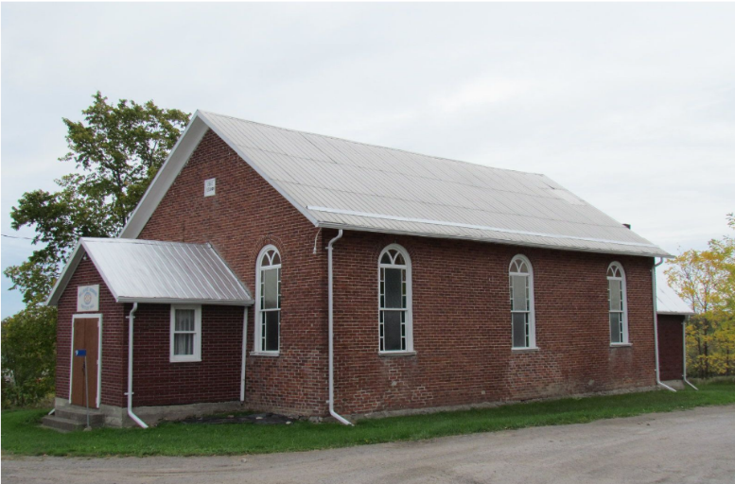
Wellman's Women’s Institute, former Wesleyan Church
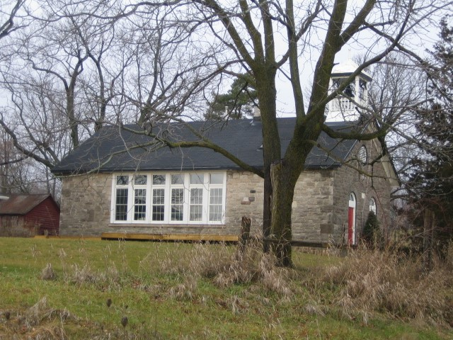
Wellman’s School is now a private home.

Polly died on April 5, 1869, in Wellman’s Corner, having lived 80 years. Daniel died on August 13, 1874, in Wellman's Corners, having lived a long life of 88 years. Daniel and Polly are buried together (just beyond the gate) in Wellman’s Corner Cemetery, Concession 5, Lot 19 Rawdon, Ontario, Canada
Note: The “Find A Grave” website lists Hubble Hill as the burial for Polly and Daniel, this is incorrect.
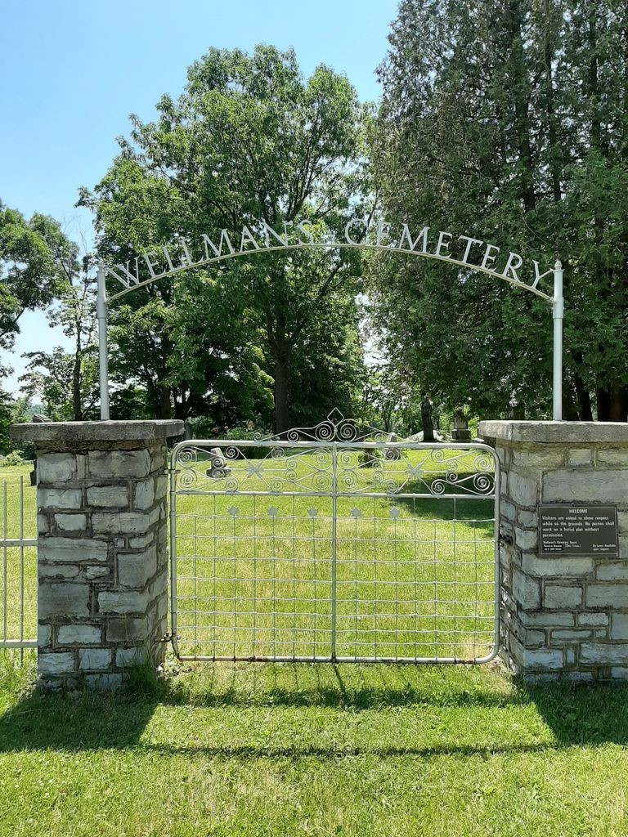
Wellman's Cemetery Entrance Gate
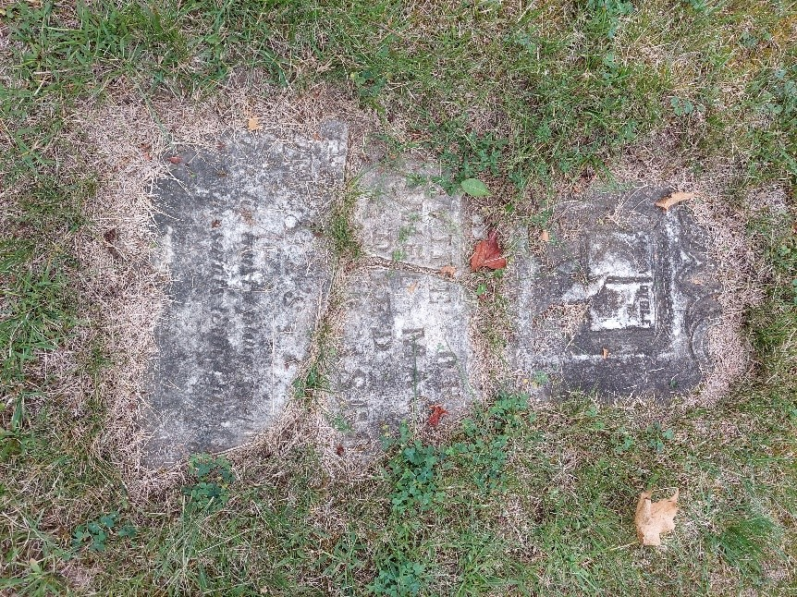
Daniel Mack’s Headstone
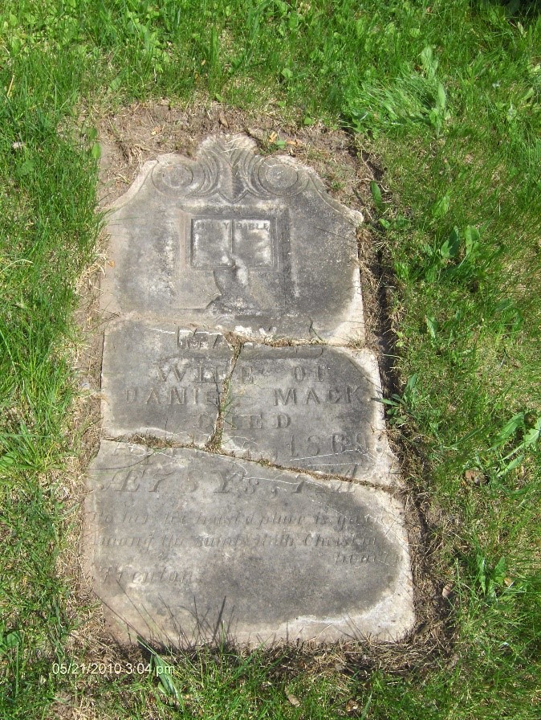
Polly Chard's Headstone

